Create Run App With Angular

- Create build file
>>ng build –prod

Angular creates a folder named dist/ in your project root.

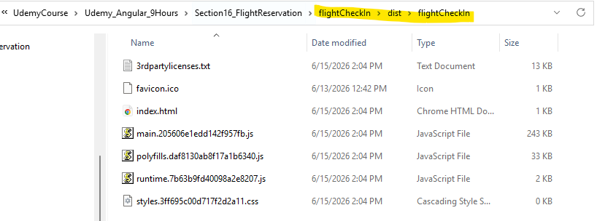

- Run the file from the dist file
>> npx http-server

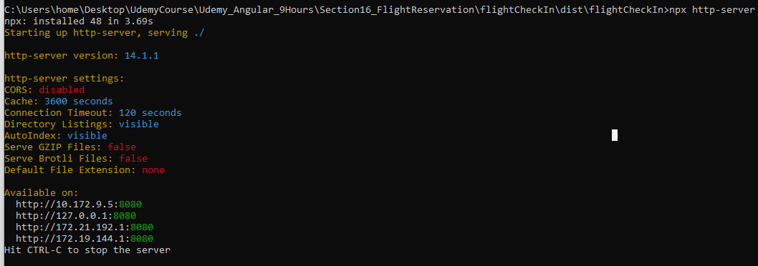

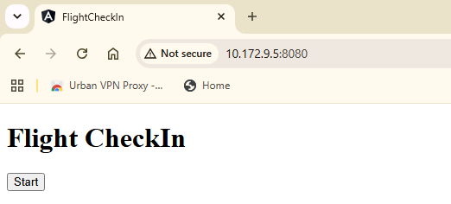

Chang port in Angular:

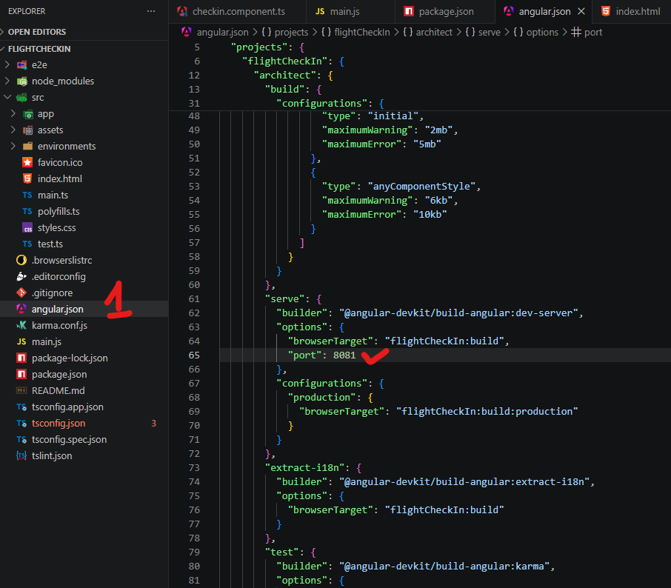

>> ng serve -o (run the app)

*Create Production File run*
>> ng build --prod
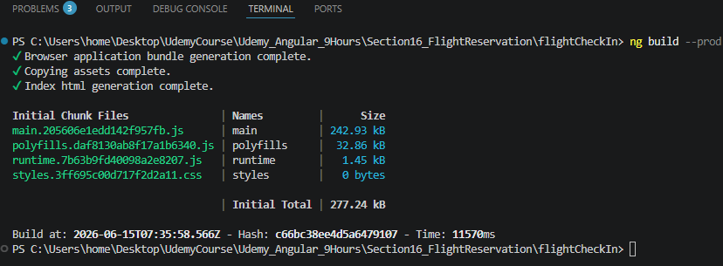

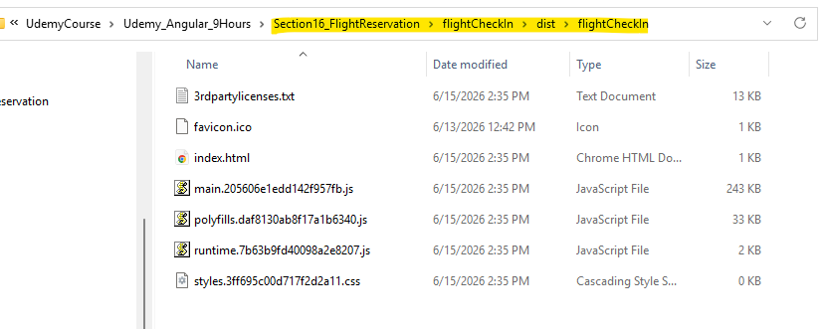

Run with specific port:
>> npx http-server -p 8081
